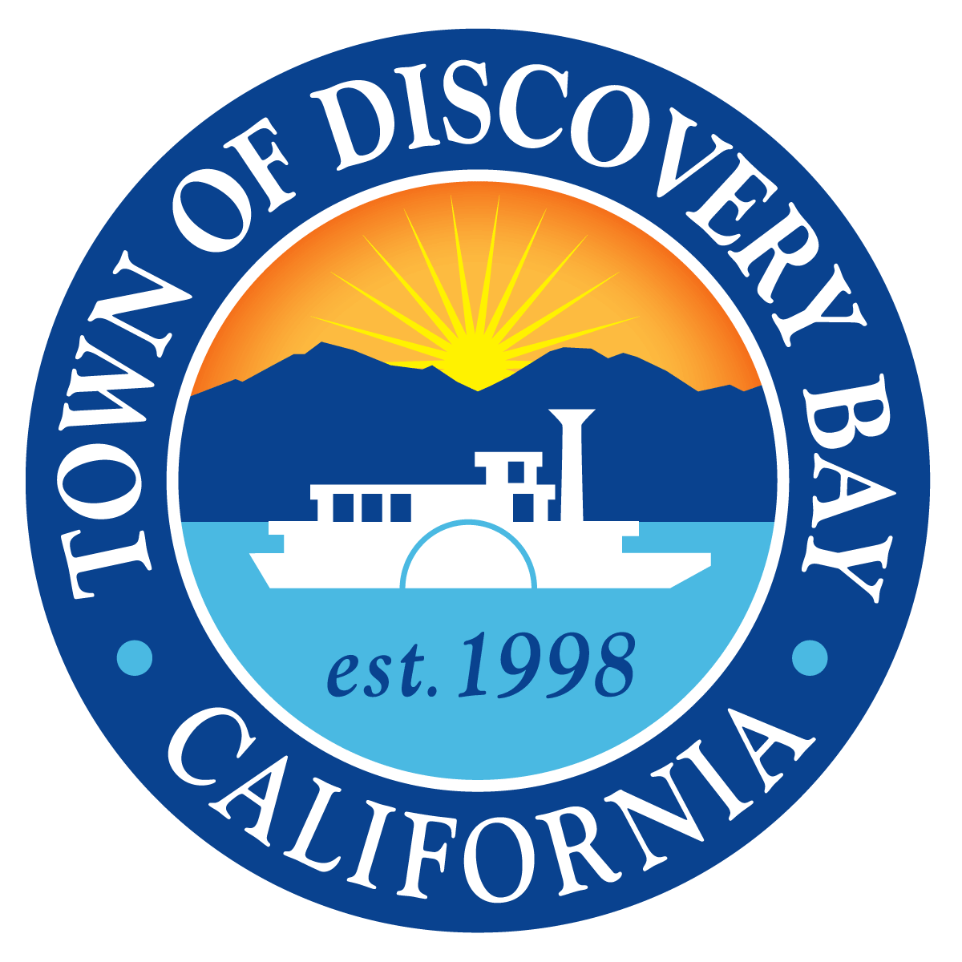

SDLF Platinum-Level of Governance

President – Kevin Graves • Vice-President – Ashley Porter • Director – Bryon Gutow • Director – Michael Callahan • Director – Carolyn Graham

TOWN OF DISCOVERY BAY A COMMUNITY SERVICES DISTRICT

MINUTES OF THE REGULAR MEETING

OF THE INTERNAL OPERATIONS COMMITTEE

OF THE TOWN OF DISCOVERY BAY
Wednesday February 2, 2022, 3:30 P.M.

NOTICE
Coronavirus COVID-19

In response to the current proclaimed State of Emergency, indoor masking requirements, and recommended measures to promote social distancing imposed by State and local officials, the Town of Discovery Bay Community Services District Board of Directors will take all actions necessary to carry out the intent and purpose of AB 361, including, ensuring that the Directors and meeting attendees may continue to have the option to access and participate in this public meeting by teleconference to avoid imminent risks to the health or safety of the Directors and meeting attendees.

To accommodate the public during this period of time that the Board’s Chambers are closed to the public, the Town of Discovery Bay Community Services District Board of Directors has arranged for members of the public to observe and address the meeting telephonically.

TO ATTEND BY WEBINAR:
Please register for the Internal Operations Committee Meeting by: (copy and pasting into your browser the registration URL. You will then be directed to download the webinar to your device and register with LogMeIn, Inc.)

Registration URL: https://attendee.gotowebinar.com/register/956617318249909773
Webinar ID# 955-985-179

After registering, you will receive a confirmation email containing information about joining the webinar by computer or by phone.

For listen only mode dial: (415) 655-0052 ID# 118-115-457

Download Agenda Packet and Materials at http://www.todb.ca.gov/

Internal Operations Committee Board Members
Chair Michael Callahan
Vice-Chair Carolyn Graham

A. ROLL CALL
- Call business meeting to order 3:30 p.m.
- Roll Call – all present

B. PUBLIC COMMENTS (Individual Public Comments will be limited to a 3-minute time limit)
1. None

C. DRAFT MINUTES TO BE APPROVED
- None.

D. PRESENTATIONS
- None.

E. DISCUSSION ITEMS
- Discussion Regarding the Implementation of a Community-Alert Text (SMS) System.
Interim Assistant General Manager Davies presented findings of research conducted on feasibility and practicality of implementing a Discovery Bay Community-Alert Text (SMS) System. Director Callahan had previously recommended SlickText. Upon further research and comparison to other vendors Interim Assistant General Manager Davies recommends that the Internal Operations Committee recommend to the Board of Directors SlickText as the Town’s initial SMS vendor. SlickText provides the best value for the Town at $79/month for 2,000 texts per month because SlickText, unlike comparable vendors, offers a rollover feature for unused texts (90 day max), 1-1 onboarding support and a customized plan with 6 Textwords which could correspond to different geographical zones of Discovery Bay. Once approved by the Board, implementation of the Community-Alert Text (SMS) System would need to be held off until the Board Secretary position is filled by permanent personnel.
Director Graham questioned: While we wait for the position to be permanently filled can we start the prep work for zoning and reaching out to HOAs to promote the service and get people signed up?
Interim Assistant General Manager Davies responded that it would be best to have all the details worked out, during the 1-1 customized plan onboarding, so we can properly announce it to the community when ready to launch.
No Public Comment.
Motion made by Director Graham.
Seconded by Director Callahan.

F. FUTURE DISCUSSION / AGENDA ITEMS
1. None

G. ADJOURNMENT
- Adjourned at 3:38 p.m. to the next Internal Operations Committee meeting at the Community Center located at 1601 Discovery Bay Boulevard.

“This agenda shall be made available upon request in alternative formats to persons with a disability, as required by the American with Disabilities Act of 1990 (42 U.S.C. § 12132) and the Ralph M. Brown Act (California Government Code § 54954.2). Persons requesting a disability related modification or accommodation in order to participate in the meeting should contact the Town of Discovery Bay, at (925) 634-1131, during regular business hours, at least forty-eight hours prior to the time of the meeting.”

"Materials related to an item on the Agenda submitted to the Town of Discovery Bay after distribution of the agenda packet are available for public inspection in the District Office located at 1800 Willow Lake Road during normal business hours."

