New User Registration Instructions

Step 1: Go to https://www.municipalonlinepayments.com/discoverybaycsdca
or use the QR code
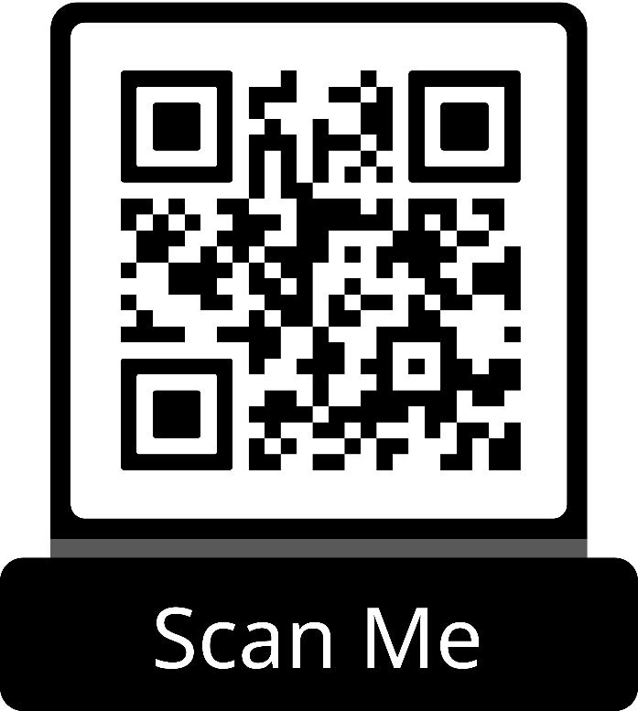

Step 2: Click Sign In / Register
Step 3: Creating a New Account
- Creating Account Step 1
  - Click on the Create an Account button at the bottom of the dialog.
  - The dialog will change for account creation.
  - As an alternative, you can create an account by signing in with one of the supported social providers.
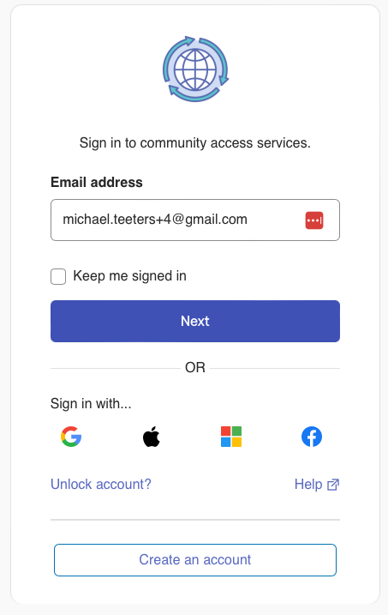
- Creating Account Step 2
  - Enter the required contact information, including email, first name, last name and a password. It's also recommended you include a mobile phone number.
  - Click on the Sign Up button when finished.
  - The dialog will change for account verification.
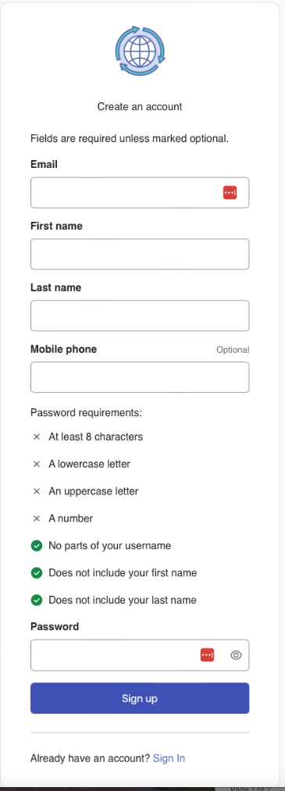

- Creating Account Step 3
  - The email address you provided will receive a verification email with a code. This confirms you have access to and can receive emails at the address.
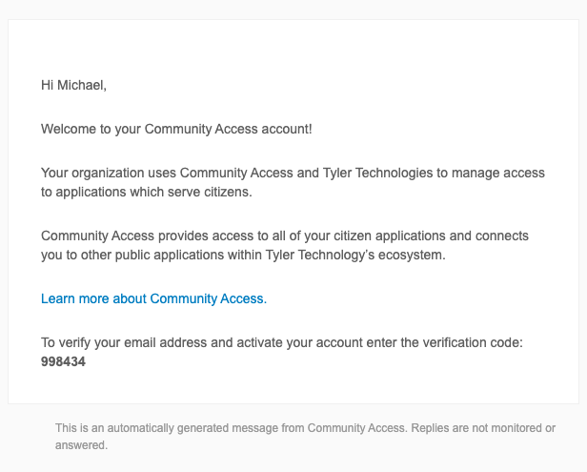

- Creating Account Step 4
  - On the Verify with your email dialog, copy to the code from the email into the Enter Code code field and click the Verify button.
  - If you've successfully verified, you'll be redirected back to where you started the sign-up process.
  - If you haven't received an email yet or weren't able to use the code in a timely manner, an option to have the code resent will be available.
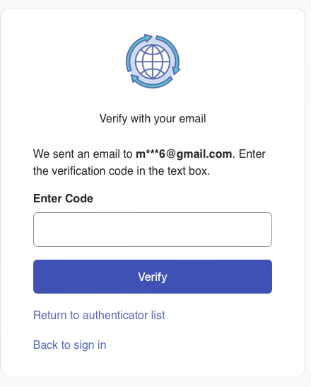
- Creating Account Step 5
  - You are now signed in using your new account on the web site or portal.
Step 4: Once you login, click on Utility Billing
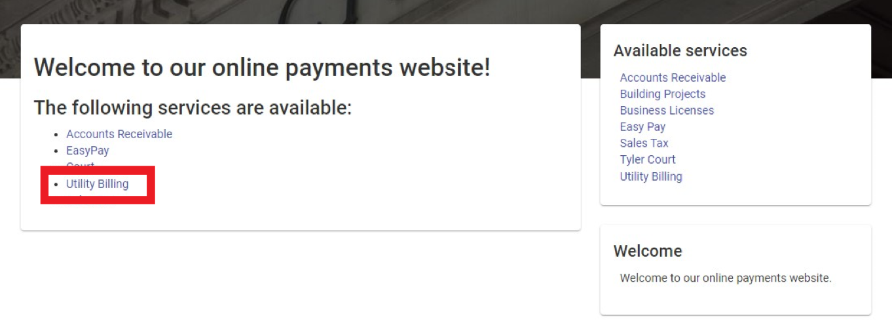
Step 5: Click Add Account
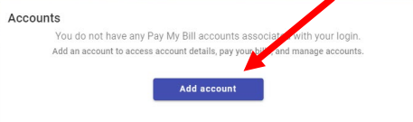
Step 6: Enter the account number and last payment account, then click Add Account. You will find your account number and last payment amount on your previous billing statement. If your account is new, then your last payment amount is zero.
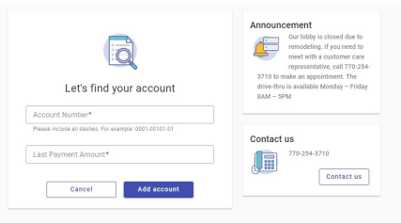 Step 7: Your account has been created! From here you can pay your bill, enroll in auto pay, or schedule a payment.

